ELP Project:

Door Security Alarm System

The system utilizes a reed switch mechanism coupled with transistor-based circuitry to create an effective security solution that alerts users when a door is opened. This simple yet functional design represents a practical application of electronic principles in creating everyday security solutions.

Circuit Diagram:

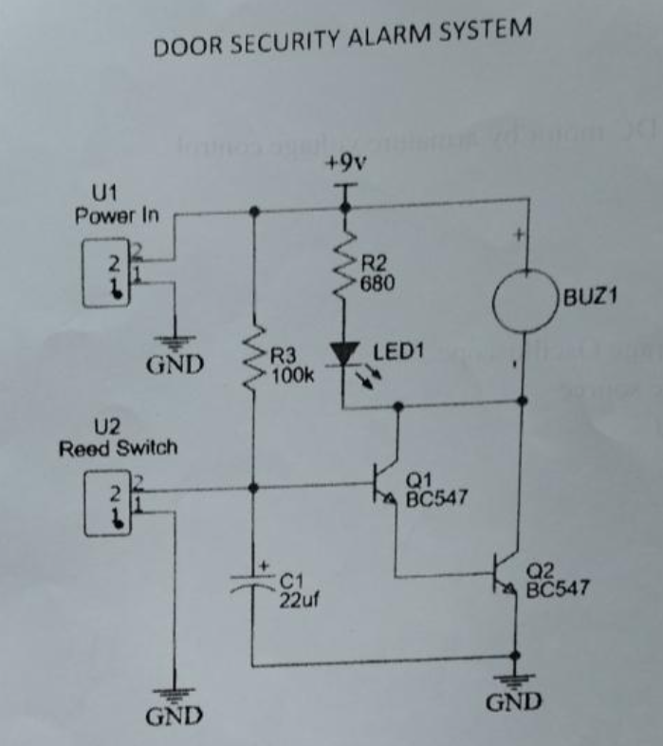

Circuit Components and Their Functions:

**Reed Switch (U2)**

The reed switch serves as the primary sensing element in this door alarm system. It consists of two ferrous metal contacts enclosed in a case that respond to magnetic fields. When a magnet is brought near the switch, these contacts pull together and close the circuit; when the magnet moves away, the contacts separate and open the circuit[2](https://www.magnelinkinc.com/blog/use-magnetic-reed-switch/). This magnetic sensitivity makes reed switches ideal for non-contact detection applications in security systems, where they function as proximity sensors that trigger alarms when a door or window is opened[2](https://www.magnelinkinc.com/blog/use-magnetic-reed-switch/)[7](https://www.reed-sensor.com/applications/).

Reed switches offer several advantages in security applications:

* They require no external power source to perform the switching action
* Function effectively in various environmental conditions
* Allow for tamper-proof installation as they can be concealed within door frames[8](https://theorycircuit.com/hobby-circuits/door-open-alarm-circuit-using-reed-switch/)

**Transistors (Q1 and Q2 - BC547)**

The circuit employs two BC547 NPN transistors that function as electronic switches to control current flow. These transistors amplify the small signal from the reed switch to drive the higher-current components (buzzer and LED)[3](https://www.gadgetronicx.com/thief-door-alarm-circuit-transistor/).

In this configuration:

* Q1 acts as the primary switch that responds to the switch state
* Q2 serves as a driver for the buzzer and LED
* Together they form a two-stage switching circuit with enhanced sensitivity and output capability[8](https://theorycircuit.com/hobby-circuits/door-open-alarm-circuit-using-reed-switch/)

NPN transistors allow current to flow from collector to emitter when sufficient current is applied to the base terminal, making them ideal for creating electronic switches in sensor circuits[3](https://www.gadgetronicx.com/thief-door-alarm-circuit-transistor/).

**Resistors (R2: 680Ω, R3: 100kΩ)**

The resistors in this circuit perform critical functions for proper operation:

* R2 (680Ω) limits current flow to the LED and connects to the positive supply, preventing component damage
* R3 (100kΩ) provides appropriate biasing for the transistor base, ensuring proper switching behavior[5](https://eepower.com/technical-articles/unraveling-passive-components-a-deep-dive-into-resistors-inductors-and-capacitors/)

Resistors control current flow to specific levels as required by the circuit, ensuring components operate within their safe parameters while maintaining proper signal levels[5](https://eepower.com/technical-articles/unraveling-passive-components-a-deep-dive-into-resistors-inductors-and-capacitors/).

**LED (LED1)**

The LED serves as a visual indicator when the alarm is triggered. When illuminated, it provides immediate visual confirmation that the door has been opened[4](https://tech-led.com/led-security-surveillance/)[9](https://www.mcbrideelectric.com/benefits-of-integrating-led-security-lighting-with-security-systems/). Modern security systems often integrate LEDs because they:

* Consume minimal power while providing bright illumination
* Have extremely long operational lifespans
* Can be easily integrated with electronic circuits
* Serve as effective deterrents when visible to potential intruders[4](https://tech-led.com/led-security-surveillance/)[9](https://www.mcbrideelectric.com/benefits-of-integrating-led-security-lighting-with-security-systems/)

**Buzzer (BUZ1)**

The buzzer generates the audible alarm when the circuit is triggered. Operating at 5V, it produces a loud sound that alerts occupants to unauthorized entry[3](https://www.gadgetronicx.com/thief-door-alarm-circuit-transistor/). In security systems, buzzers:

* Provide immediate audible notification of breaches
* Act as psychological deterrents to intruders
* Alert occupants even when they aren't within visual range of the LED indicator[3](https://www.gadgetronicx.com/thief-door-alarm-circuit-transistor/)[8](https://theorycircuit.com/hobby-circuits/door-open-alarm-circuit-using-reed-switch/)

**Capacitor (C1: 22μF)**

The 22μF capacitor serves multiple purposes in this circuit:

* Filters out electrical noise that might cause false triggering
* Provides a slight delay in the triggering mechanism to prevent momentary fluctuations from activating the alarm( Since, it takes some time to charge)
* Works with the resistors to create timing effects for the circuit operation[5](https://eepower.com/technical-articles/unraveling-passive-components-a-deep-dive-into-resistors-inductors-and-capacitors/)

Capacitors store electrical energy as an electric field across their plates, enabling functions like energy storage, filtering, and signal coupling in electronic systems[5](https://eepower.com/technical-articles/unraveling-passive-components-a-deep-dive-into-resistors-inductors-and-capacitors/).

**Power Supply (9V)**

The 9V battery provides the necessary electrical power for the entire circuit. This portable power source allows for installation without requiring connection to mains electricity, making the alarm system versatile and easy to deploy[6](https://1stalarm.com/how-does-a-home-security-system-door-sensor-work/).

Circuit Operation Mechanism:

**Normal State (Door Closed)**

When the door is closed:

1. The magnet attached to the door is positioned close to the reed switch
2. The magnetic field causes the reed switch contacts to close
3. This provides a path for current to flow through the switch
4. The closed switch connects the base of Q1 to ground through C1
5. With its base at ground potential, Q1 remains in OFF state
6. Since Q1 is OFF, no current flows to the base of Q2
7. Q2 remains OFF, preventing current from flowing through the buzzer and LED
8. The alarm remains silent and the LED remains unlit[3](https://www.gadgetronicx.com/thief-door-alarm-circuit-transistor/)[8](https://theorycircuit.com/hobby-circuits/door-open-alarm-circuit-using-reed-switch/)

**Alarm State (Door Opened)**

When the door is opened:

1. The magnet moves away from the reed switch
2. Without the magnetic field, the reed switch contacts open
3. The base of Q1 is now pulled up through resistor R3
4. Q1 turns ON and conducts current
5. This provides base current to Q2, turning it ON
6. Q2 conducts, allowing current to flow through the buzzer and LED
7. The buzzer sounds and the LED illuminates, signaling that the door has been opened[3](https://www.gadgetronicx.com/thief-door-alarm-circuit-transistor/)[6](https://1stalarm.com/how-does-a-home-security-system-door-sensor-work/)[8](https://theorycircuit.com/hobby-circuits/door-open-alarm-circuit-using-reed-switch/)

This elegant switching mechanism ensures that the alarm activates only when the door is opened, providing reliable security monitoring.

Applications and Significance

**Home Security Applications**

Door alarm systems serve as fundamental components in residential security:

* Monitoring entry points to detect unauthorized access
* Providing immediate notification when doors are opened
* Protecting family members and valuable possessions[6](https://1stalarm.com/how-does-a-home-security-system-door-sensor-work/)[7](https://www.reed-sensor.com/applications/)

These systems can be installed on any door where security monitoring is desired, including front doors, back doors, garage entrances, and even windows.

**Commercial Security Applications**

In commercial settings, door alarm systems offer enhanced protection:

* Monitoring access to restricted areas
* Protecting inventory and sensitive equipment
* Alerting security personnel to unauthorized entry[2](https://www.magnelinkinc.com/blog/use-magnetic-reed-switch/)[7](https://www.reed-sensor.com/applications/)

When LED security lighting is integrated with door alarm systems, the effectiveness of both is maximized. The alarm can trigger lights to illuminate when breaches occur, providing better visibility and further deterring intruders[9](https://www.mcbrideelectric.com/benefits-of-integrating-led-security-lighting-with-security-systems/).

**Educational Value**

This circuit also serves as an excellent educational tool:

* Demonstrates practical application of electronic principles
* Teaches circuit design and component functions
* Introduces security system concepts
* Provides hands-on experience with circuit construction

Voltage Table:

|  |  |  |
| --- | --- | --- |
|  | ON | OFF |
| Buzzer | 6.5V | 0V |
| LED1 | 2.9V | 0V |
| V,R2 | 3.6V | 0V |
| V, R3 | 7.83V | 9.15V |
| V, C1 | 1.3V | 0V |
| V,Q1 | Vcb = 1.3V | Vcb = 8.88V |
|  | Vbe = 0.6 | Vbe = 0V |
|  | Vce = 2V | Vce = 6.55V |
| V,Q2 | Vcb = 1.9V | Vcb = 6.55V |
|  | Vbe = 0.7V | Vbe = 0V |
|  | Vce = 2.6V | Vce = 8.8V |

Calculations:

When Circuit is in on mode, Current flowing through resistance R2 = 5mA

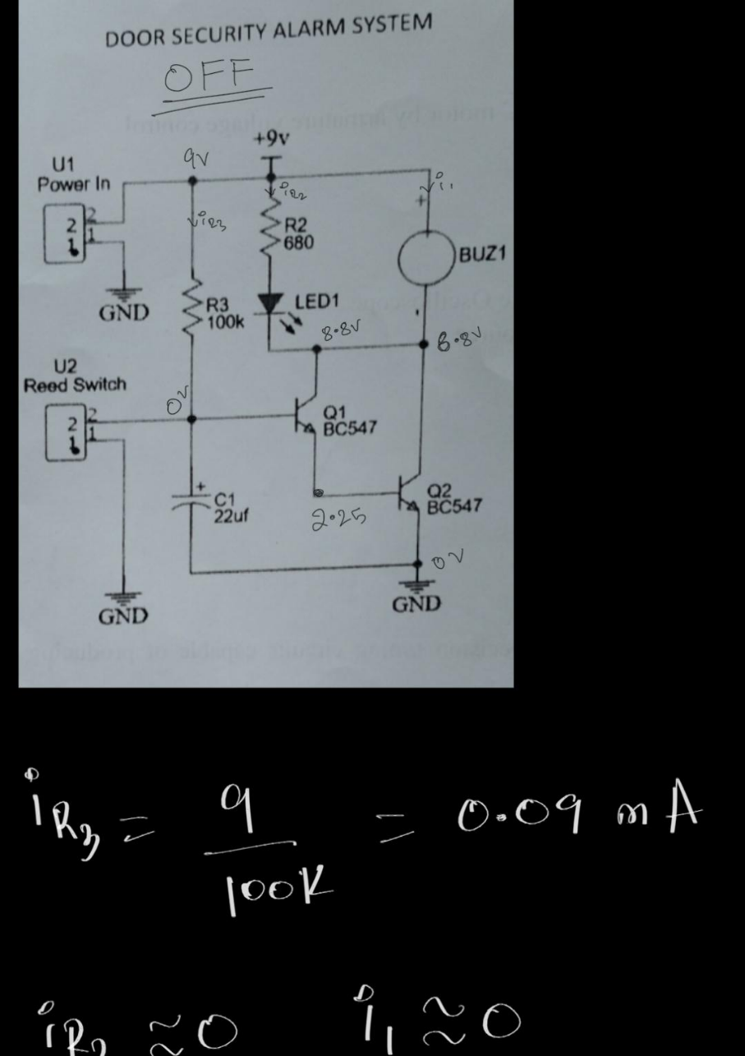

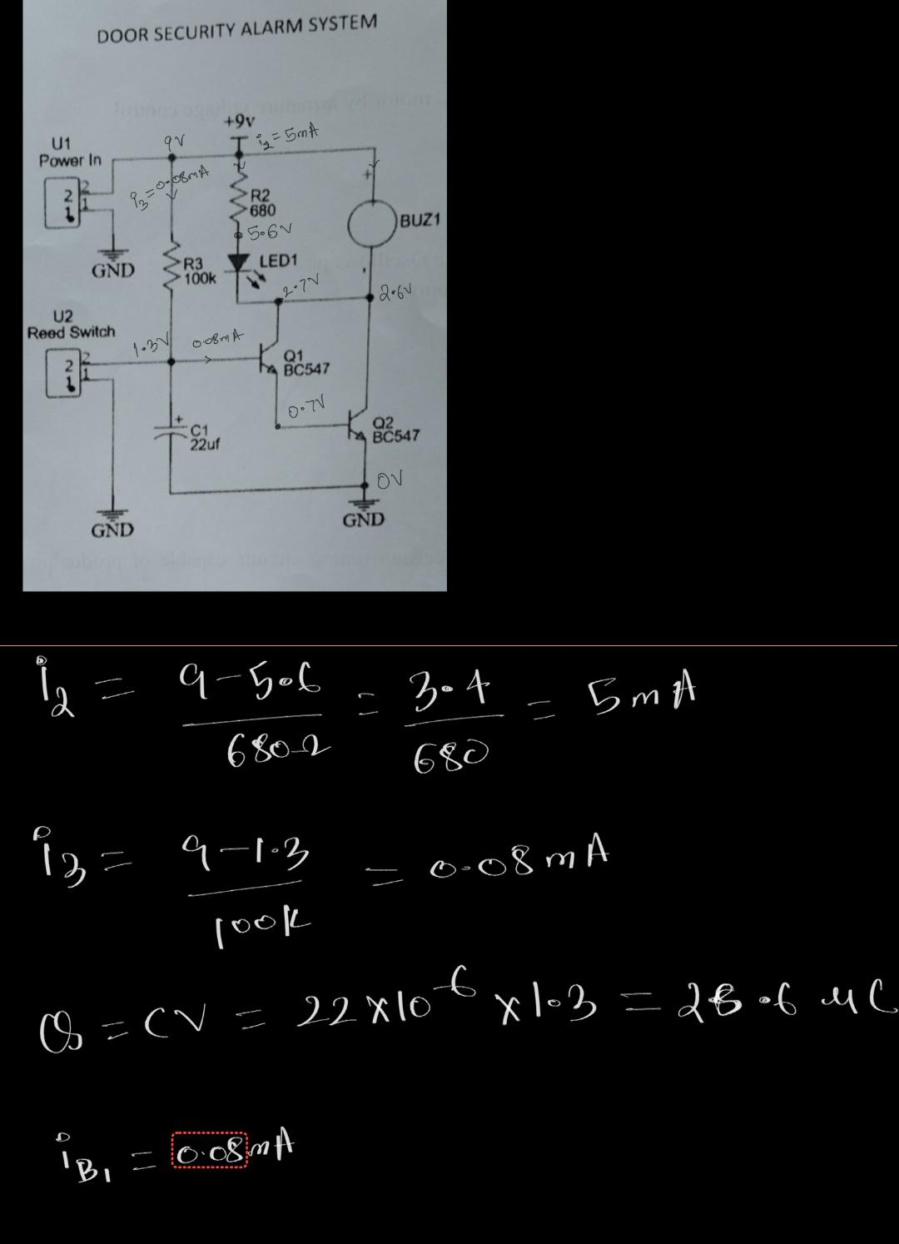

Project Video Link:

[rb.gy/h19fp4](https://rb.gy/h19fp4)

Photos Taken During the project:

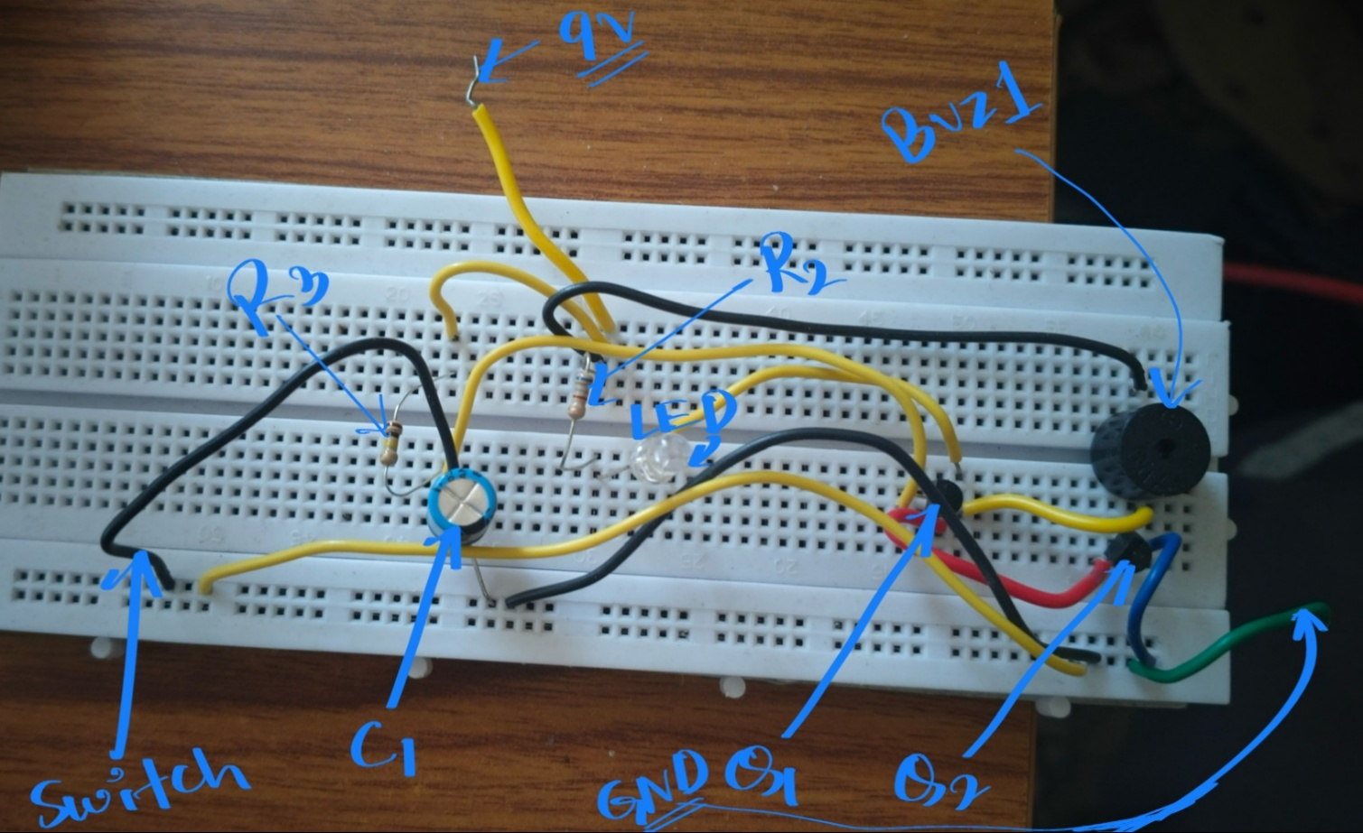



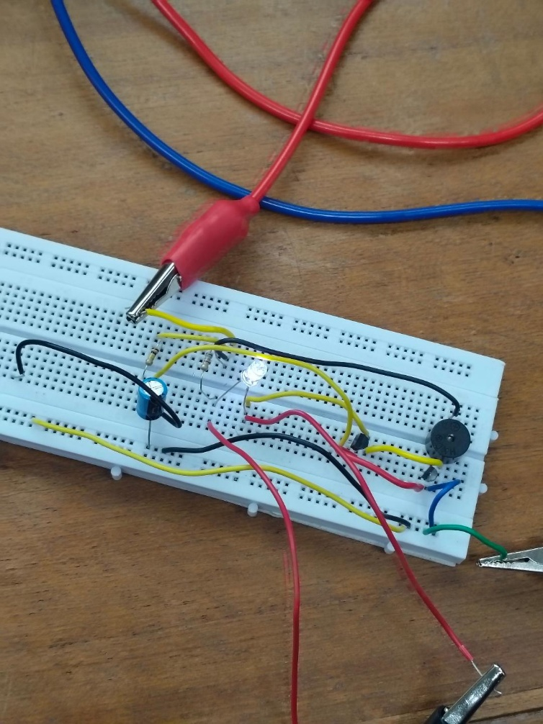

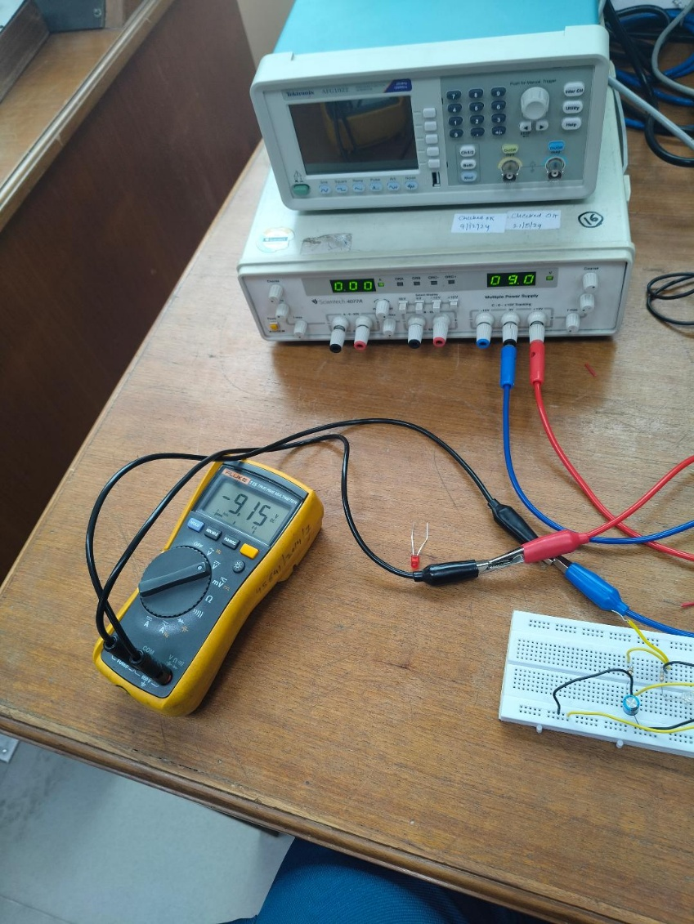

Conclusion

The door security alarm system presented in this report represents an efficient and practical application of electronic principles to create a functional security solution. By utilizing a reed switch/ simply a wire as a sensor and employing transistor-based switching circuitry, the system reliably detects door openings and provides both visual and audible alerts.

The significance of this system extends beyond its technical design. As security concerns continue to grow in both residential and commercial settings, simple yet effective solutions like this door alarm provide accessible security options for various applications. The system's battery-powered operation, minimal component requirements, and straightforward installation make it particularly valuable for locations where more complex security systems might be impractical or cost-prohibitive.

Future enhancements could include integration with wireless communication modules, smartphone connectivity, or additional sensors to create more comprehensive security solutions. However, even in its current form, this door security alarm system demonstrates how basic electronic components can be combined to create practical devices that address real-world security needs

Name: Reyansh Thigulla Entry No. 2024MT11136 Group. 37

Name: Manasvi Entry No. 2024MT10138 Group. 37